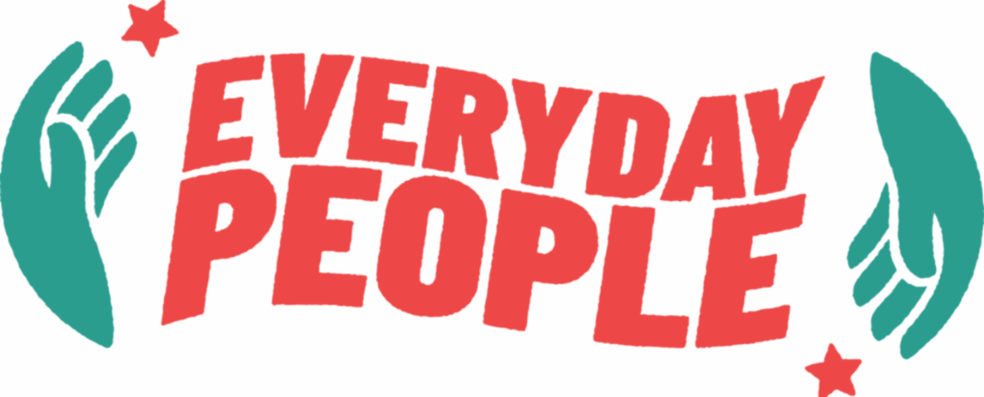

Dear __________,

I wanted to take a moment to introduce you to a new organization and grassroots effort. Called Everyday People, it's a movement to drive white supremacists out of power; not just in the federal government, but everywhere.

I know, right?

Here's the thing: Ten years ago, a white supremacist murdered nine Black people and injured another in the Mother Emanuel shooting here in Charleston. It broke us. As it should have. The murderer later said he wasn't afraid of the death penalty or a lengthy prison sentence, because at some point in the future, he would be "rescued by white nationalists after they took over the government."

Well, white nationalists have taken over the government, and yes, white supremacy is as American as apple pie, but we're still somehow in new territory. Threats compound. Immigrants, education, trans people, the land itself are under new and more violent attack. We cannot sit idly by. We are also committed to non-violence. So, as Everyday People tired of living beneath the cruelty of white supremacy, we must act.

How? A nationwide fast. Not from food or drink. (Unless you want to do that as part of a spiritual commitment to the effort.) But from spending. Every Friday, from midnight to midnight, we won't buy anything. Not gas. Not groceries. Not a birthday present for our nephew. Instead, if we need something, we will plan ahead. Or, we will ask someone for it. Or, we will go without. So much of white supremacist violence exists and is perpetuated to funnel money into the pockets of the rich. So, one day a week, we won't participate in their money laundering scheme.

We're calling it Fasting Fridays, and it's as simple as it sounds. You just don't buy anything on Fridays. Along the way to reaching our goal of no more white supremacists in power anywhere across the land, we think we'll hit some benchmarks. We've defined ten, and they're aimed at the federal government. They are:

* Bring back DEI
* Hands off education
* Economic justice
* Hands off immigrants
* Guarantee trans rights & safety
* Guarantee Palestinian safety, right of return & aid
* Hands off disabled people
* Reproductive rights
* Reduce policing and incarceration
* Protect the planet

They're big benchmarks. You can read more about them [here](https://everydaypeoplefast.com) and sign up to participate in the fast. We encourage participants to define local and state benchmarks, too. As Everyday People, we have to do something. The future is here, and it's not what we wanted. We can change that. One Friday at a time.

Are you in?

Sincerely/Love/In Solidarity,

[Name]

